Outline:

1. Paper Title
2. Methodology Used
3. Problems solved in the paper
4. Problems in the given Paper

Paper Link : [(PDF) Application of Human Posture Recognition Based on the Convolutional Neural Network in Physical Training Guidance (researchgate.net)](https://www.researchgate.net/publication/361613283_Application_of_Human_Posture_Recognition_Based_on_the_Convolutional_Neural_Network_in_Physical_Training_Guidance)

More Paper Summary @ [Github Notebooks Repo](https://github.com/SianRods/IPD-Research)

Problems in Traditional Methods:

1. The traditional athlete posture recognition and estimation methods cannot fully extract image features.
2. when the athlete’s posture changes greatly in training, the error between the estimation results and the actual results will become larger Therefore, estimating the posture recognition of skilled athletes in complex environment has become a challenge for sports video analysis technology.
3. Body pose estimation by body parts is prone to loss of body information, while the bottom-up approach increases the chances of joint point misdetection.

Solutions Offered in the Paper:

1. This study creatively constructs a layered hourglass network based on improved module, multiscale module, and large perception field module. The intermediate supervision method is used to avoid the gradient vanishing problem of the convolutional neural network. Compared with the traditional athlete posture estimation method in image feature information extraction, this method has more practical application value.
2. It solves the problem that there is a large error between the estimated results and the actual results when the environment in the sports video is complex or the athletes’ body parts are blocked.
3. Convolutional neural networks have the unique advantage of being feed forward neural networks with deep structure. Although the performance of the convolutional neural network in athlete posture estimation is better than that of traditional methods, there are still some problems, such as gradient problem and small sensing domain of the feed forward network. Therefore, this study selects a convolutional neural network with stacked hourglass structure and improves it combined with multiple modules
4. The superimposed hourglass grid is constructed using grid and intermediate supervision method, which not only solves the problem of gradient disappearance, but also has high network performance and athlete attitude estimation accuracy. The performance of a single module cannot meet the requirements of athletes’ posture estimation technology. Therefore, this study selects large sensory field module, improved module, and multiscale module for network construction.

Approach:

1. Normal Convolutional Neural Networks Architecture is modified
2. Convolutional Layers
3. Pooling Layers
4. 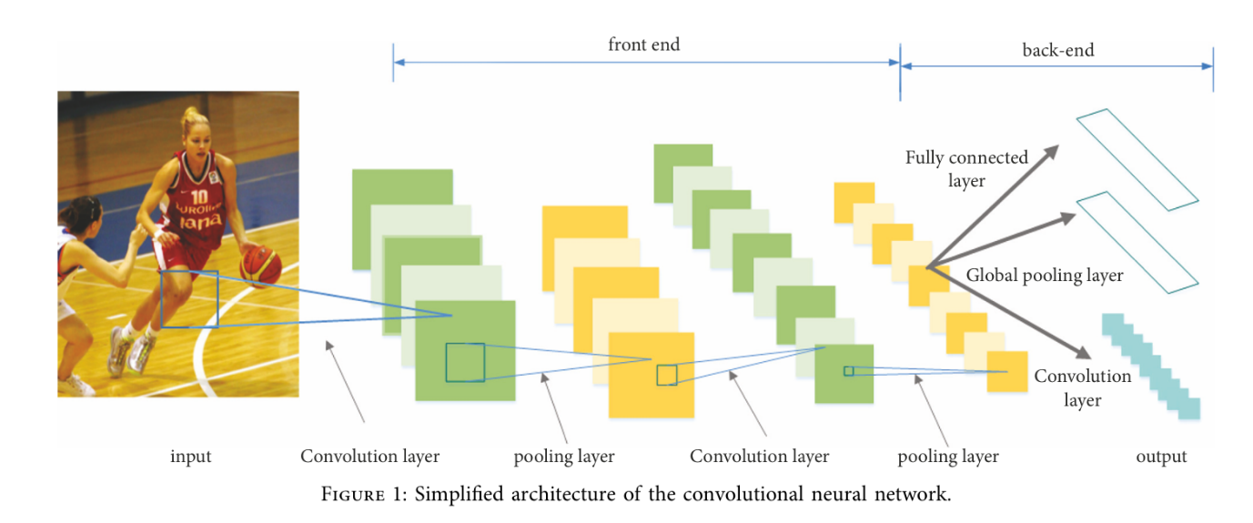Fully Connected Layers ,etc
5. 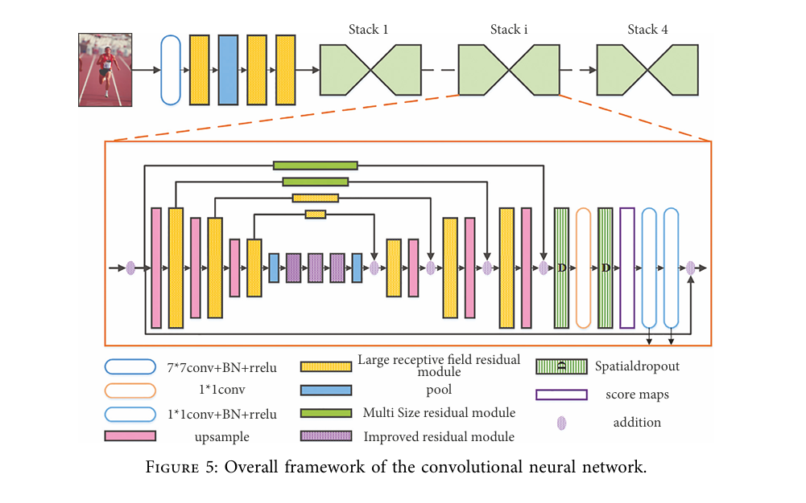Here Hourglass Grid Neural Network Architecture is Used which is specifically designed for capturing both the high level context and Fine grained details.Here several Hourglass Grid Layers are stacked after Convolutional and Pooling Layers

The overall framework of the convolutional neural network. As shown in the figure, it can be divided into two parts, the first half and the second half. The first half of the framework is composed of convolution, large field of view module, and pool, which is used to learn athletes’ pose estimation in the feature map. After convolution kernel operation, the size of the feature map remains in the second half. e second half of the frame is composed of hourglass sub grid structure, with intermediate supervision at the end of each hourglass, and the feature map is processed multiple times between high resolution and first resolution to form a stacked hourglass grid.

1. Use of Large Receptive Field Residual Module

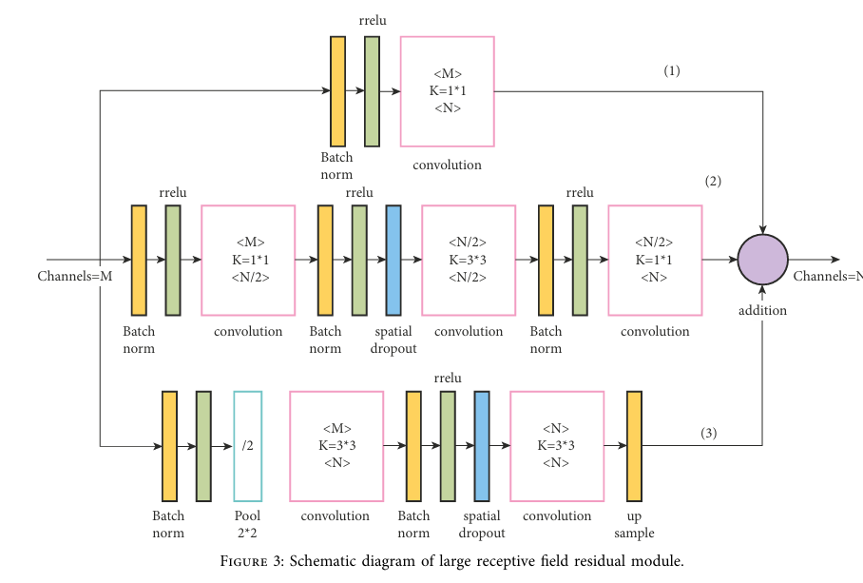

This Model definitely yields better results and Lower Loss due to Complex Environments using the Hourglass grid Architecture.

Limitations of Study:

This method only estimates the pose of a single athlete in the sports game video and cannot solve the pose estimation problem of multiple athletes. It has shortcomings in practical application and needs further research.